Fractals
Fractals are mathematical sets, usually obtained through recursion, that exhibit interesting dimensional properties. We’ll explore what that sentence means through the rest of the chapter. For now, we can begin with the idea of self-similarity, a characteristic of most fractals.

Self-similarity
A shape is self-similar when it looks essentially the same from a distance as it does closer up.

Self-similarity can often be found in nature. In the Romanesco broccoli pictured below, if we zoom in on part of the image, the piece remaining looks similar to the whole.
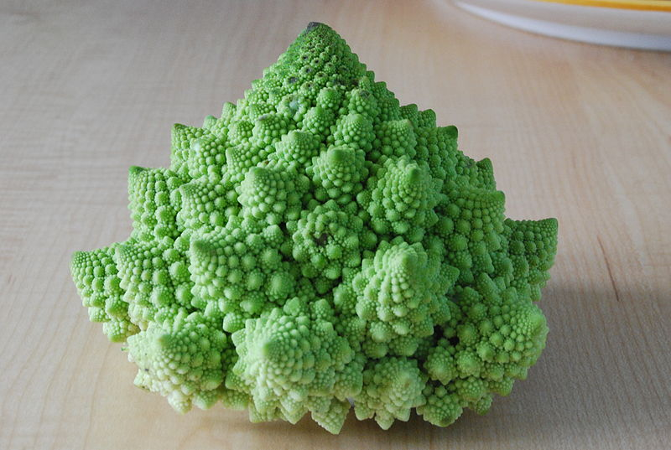

Likewise, in the fern frond below, one piece of the frond looks similar to the whole.
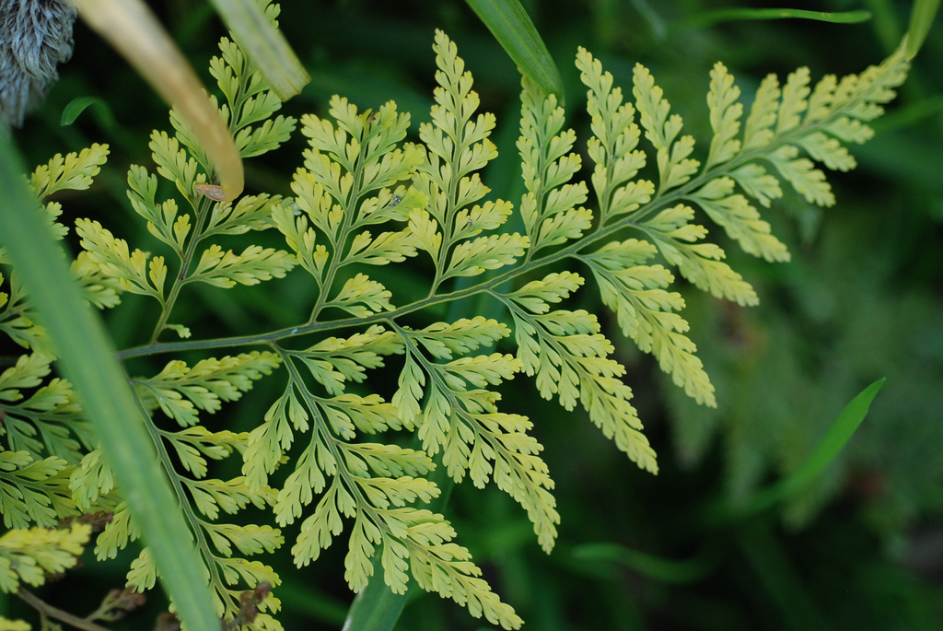

Similarly, if we zoom in on the coastline of Portugal, each zoom reveals previously hidden detail, and the coastline, while not identical to the view from further way, does exhibit similar characteristics.

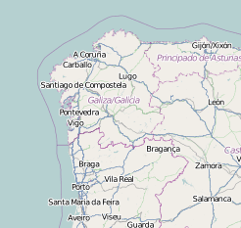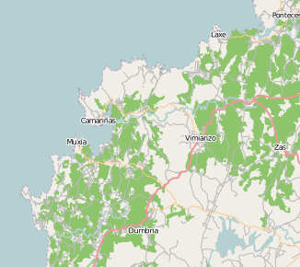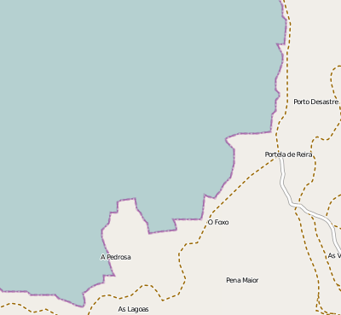

Iterated Fractals
This self-similar behavior can be replicated through recursion: repeating a process over and over.

Example 1
Suppose that we start with a filled-in triangle. We connect the midpoints of each side and remove the middle triangle. We then repeat this process.

Initial
Step 1
Step 2

Step 3

If we repeat this process, the shape that emerges is called the Sierpinski gasket. Notice that it exhibits self-similarity – any piece of the gasket will look identical to the whole. In fact, we can say that the Sierpinski gasket contains three copies of itself, each half as tall and wide as the original. Of course, each of those copies also contains three copies of itself.

We can construct other fractals using a similar approach. To formalize this a bit, we’re going to introduce the idea of initiators and generators.

Initiators and Generators
An initiator is a starting shape
A generator is an arranged collection of scaled copies of the initiator
To generate fractals from initiators and generators, we follow a simple rule:

Fractal Generation Rule
At each step, replace every copy of the initiator with a scaled copy of the generator, rotating as necessary

This process is easiest to understand through example.

Example 2
Use the initiator and generator shown to create the iterated fractal.
initiator
generator

This tells us to, at each step, replace each line segment with the spiked shape shown in the generator. Notice that the generator itself is made up of 4 copies of the initiator. In step 1, the single line segment in the initiator is replaced with the generator. For step 2, each of the four line segments of step 1 is replaced with a scaled copy of the generator:
Step 1
Scaled copy of generator
A scaled copy replaces each line segment of Step 1
Step 2

This process is repeated to form Step 3. Again, each line segment is replaced with a scaled copy of the generator.
Step 2
Scaled copy of generator
Step 3
Notice that since Step 0 only had 1 line segment, Step 1 only required one copy of Step 0.
Since Step 1 had 4 line segments, Step 2 required 4 copies of the generator.
Step 2 then had 16 line segments, so Step 3 required 16 copies of the generator.
Step 4, then, would require 16*4 = 64 copies of the generator.
Koch curve
The shape resulting from iterating this process is called the Koch curve, named for Helge von Koch who first explored it in 1904.

Notice that the Sierpinski gasket can also be described using the initiator-generator approach
Initiator
Generator

Example 3
Use the initiator and generator below, however only iterate on the “branches.” Sketch several steps of the iteration.
initiator
generator

We begin by replacing the initiator with the generator. We then replace each “branch” of Step 1 with a scaled copy of the generator to create Step 2.
Step 1
Step 2
We can repeat this process to create later steps. Repeating this process can create intricate tree shapes.
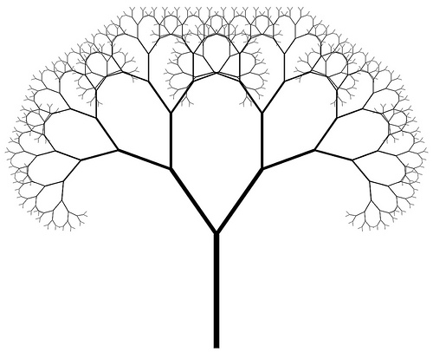
Step 3
Step 4
Final shape

Try it Now 1
Use the initiator and generator shown to produce the next two stages
Initiator
Generator

Using iteration processes like those above can create a variety of beautiful images evocative of nature.

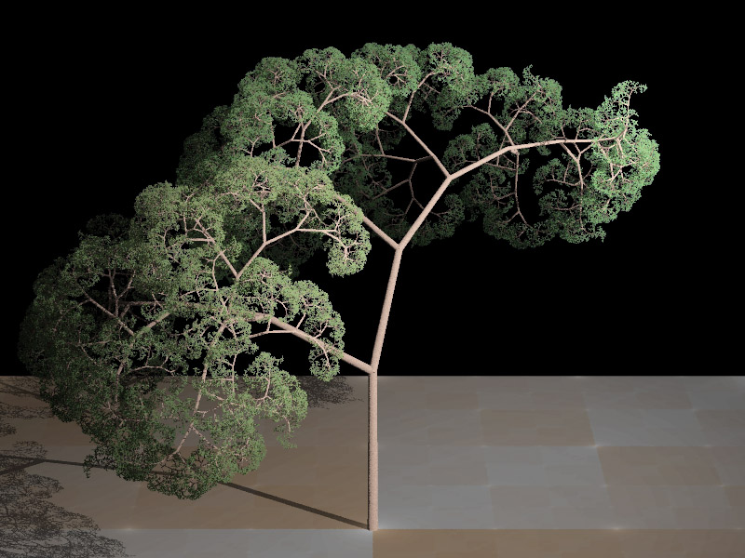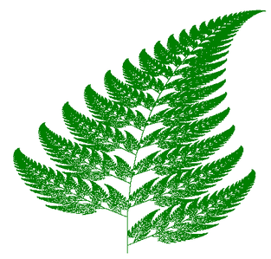

More natural shapes can be created by adding in randomness to the steps.

Example 4
Create a variation on the Sierpinski gasket by randomly skewing the corner points each time an iteration is made.

Suppose we start with the triangle below. We begin, as before, by removing the middle triangle. We then add in some randomness.
Step 0
Step 1
Step 1 with randomnesss
We then repeat this process.
Step 1 with randomnesss

Step 2
Step 2 with randomnesss
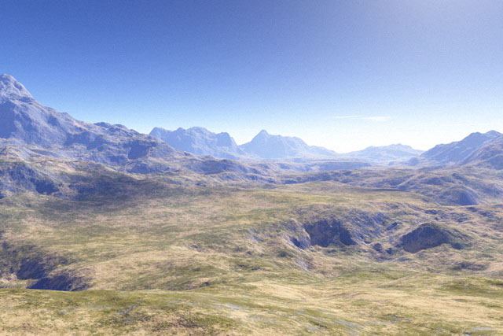
Continuing this process can create mountain-like structures.

The landscape to the right was created using fractals, then colored and textured.

Fractal Dimension
In addition to visual self-similarity, fractals exhibit other interesting properties. For example, notice that each step of the Sierpinski gasket iteration removes one quarter of the remaining area. If this process is continued indefinitely, we would end up essentially removing all the area, meaning we started with a 2-dimensional area, and somehow end up with something less than that, but seemingly more than just a 1-dimensional line.

To explore this idea, we need to discuss dimension. Something like a line is 1-dimensional; it only has length. Any curve is 1-dimensional. Things like boxes and circles are 2-dimensional, since they have length and width, describing an area. Objects like boxes and cylinders have length, width, and height, describing a volume, and are 3-dimensional.
1-dimensional2-dimensional3-dimensional

Certain rules apply for scaling objects, related to their dimension.

If I had a line with length 1, and wanted scale its length by 2, I would need two copies of the original line. If I had a line of length 1, and wanted to scale its length by 3, I would need three copies of the original.
1
2
3

If I had a rectangle with length 2 and height 1, and wanted to scale its length and width by 2, I would need four copies of the original rectangle. If I wanted to scale the length and width by 3, I would need nine copies of the original rectangle.
1
4
6
2
2
3

If I had a cubical box with sides of length 1, and wanted to scale its length and width by 2, I would need eight copies of the original cube. If I wanted to scale the length and width by 3, I would need 27 copies of the original cube.
1
2
3
1
1
2
2
3
3

Notice that in the 1-dimensional case, copies needed = scale.
In the 2-dimensional case, copies needed = scale².
In the 3-dimensional case, copies needed = scale³.

From these examples, we might infer a pattern.

Scaling-Dimension Relation
To scale a D-dimensional shape by a scaling factor S, the number of copies C of the original shape needed will be given by:

Copies = Scale^{Dimension} , or C = S^{D}

Example 5
Use the scaling-dimension relation to determine the dimension of the Sierpinski gasket.
1
2
Suppose we define the original gasket to have side length 1. The larger gasket shown is twice as wide and twice as tall, so has been scaled by a factor of 2.

Notice that to construct the larger gasket, 3 copies of the original gasket are needed.

Using the scaling-dimension relation C = S^{D}, we obtain the equation 3 = 2^{D}.

Since 2¹ = 2 and 2² = 4, we can immediately see that D is somewhere between 1 and 2; the gasket is more than a 1-dimensional shape, but we’ve taken away so much area its now less than 2-dimensional.

Solving the equation 3 = 2^{D} requires logarithms. If you studied logarithms earlier, you may recall how to solve this equation (if not, just skip to the box below and use that formula):

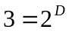 Take the logarithm of both sides
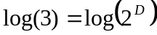 Use the exponent property of logs
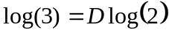 Divide by log(2)
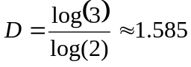 The dimension of the gasket is about 1.585

Scaling-Dimension Relation, to find Dimension
To find the dimension D of a fractal, determine the scaling factor S and the number of copies C of the original shape needed, then use the formula
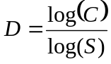

Try it Now 2
Determine the fractal dimension of the fractal produced using the initiator and generator
Initiator
Generator

We will now turn our attention to another type of fractal, defined by a different type of recursion. To understand this type, we are first going to need to discuss complex numbers.

Complex Numbers
The numbers you are most familiar with are called real numbers. These include numbers like 4, 275, -200, 10.7, ½, π, and so forth. All these real numbers can be plotted on a number line. For example, if we wanted to show the number 3, we plot a point:
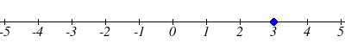

To solve certain problems like x² = –4, it became necessary to introduce imaginary numbers.

Imaginary Number i
The imaginary number i is defined to be 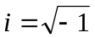.
Any real multiple of i, like 5i, is also an imaginary number.

Example 6
Simplify 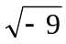.

We can separate as 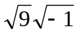. We can take the square root of 9, and write the square root of -1 as i.
=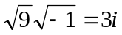

A complex number is the sum of a real number and an imaginary number.

Complex Number
A complex number is a number 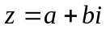, where a and b are real numbers
a is the real part of the complex number
b is the imaginary part of the complex number

To plot a complex number like 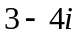, we need more than just a number line since there are two components to the number. To plot this number, we need two number lines, crossed to form a complex plane.

Complex Plane
real
imaginary
In the complex plane, the horizontal axis is the
real axis and the vertical axis is the imaginary axis.

Example 7
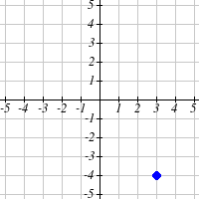
Plot the number on the complex plane.
imaginary

The real part of this number is 3, and the imaginary part is -4. To plot this, we draw a point 3 units to the right of the origin in the horizontal direction and 4 units down in the vertical direction.
real

Because this is analogous to the Cartesian coordinate system for plotting points, we can think about plotting our complex number as if we were plotting the point (a, b) in Cartesian coordinates. Sometimes people write complex numbers as 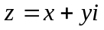 to highlight this relation.

Arithmetic on Complex Numbers
Before we dive into the more complicated uses of complex numbers, let’s make sure we remember the basic arithmetic involved. To add or subtract complex numbers, we simply add the like terms, combining the real parts and combining the imaginary parts.

Example 8
Add and 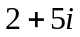.

Adding 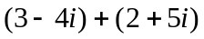, we add the real parts and the imaginary parts
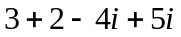
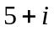

Try it Now 3
Subtract from

When we add complex numbers, we can visualize the addition as a shift, or translation, of a point in the complex plane.

Example 9
Visualize the addition and 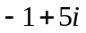.
imaginary
real
3 – 4i
2 + 1i

The initial point is . When we add 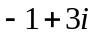, we add -1 to the real part, moving the point 1 units to the left, and we add 5 to the imaginary part, moving the point 5 units vertically. This shifts the point to 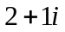

We can also multiply complex numbers by a real number, or multiply two complex numbers.

Example 10
Multiply: 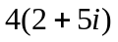.

To multiply the complex number by a real number, we simply distribute as we would when multiplying polynomials.

Distribute
=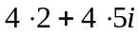 Simplify
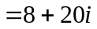

Example 11
Multiply: 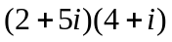.

Expand
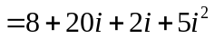 Since , 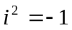
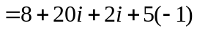 Simplify
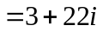

Try it Now 4
Multiply and 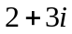.

To understand the effect of multiplication visually, we’ll explore three examples.

Example 12
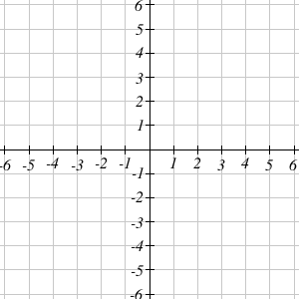
Visualize the product 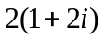
imaginary
real
2 +4i
1 + 2i

Multiplying we’d get
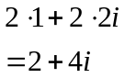

Notice both the real and imaginary parts have been scaled by 2. Visually, this will stretch the point outwards, away from the origin.

Example 13
Visualize the product 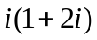

Multiplying, we’d get
imaginary
real
–2 + i
1 + 2i
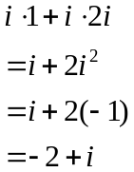

In this case, the distance from the origin has not changed, but the point has been rotated about the origin, 90° counter-clockwise.

Example 14
Visualize the result of multiplying 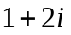 by 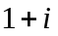. Then show the result of multiplying by again.
imaginary
real
–1+3i
1+2i
–6 – 2i

Multiplying by ,
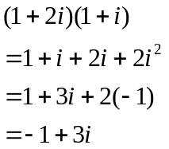
-4+2i

Multiplying by 1 + i again,
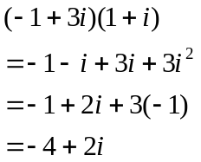

If we multiplied by 1+i again, we’d get –6–2i. Plotting these numbers in the complex plane, you may notice that each point gets both further from the origin, and rotates counterclockwise, in this case by 45°.

In general, multiplication by a complex number can be thought of as a scaling, changing the distance from the origin, combined with a rotation about the origin.

Complex Recursive Sequences
We will now explore recursively defined sequences of complex numbers.

Recursive Sequence
A recursive relationship is a formula which relates the next value, 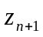, in a sequence to the previous value, 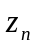. In addition to the formula, we need an initial value, 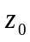.

The sequence of values produced is the recursive sequence.

Example 15
Given the recursive relationship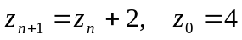, generate several terms of the recursive sequence.

We are given the starting value, 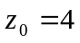. The recursive formula holds for any value of n, so if n = 0, then 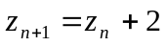 would tell us 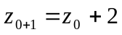, or more simply, 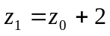.

Notice this defines 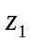 in terms of the known , so we can compute the value:
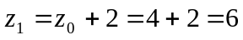.

Now letting n = 1, the formula tells us 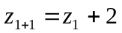, or 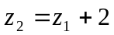. Again, the formula gives the next value in the sequence in terms of the previous value.
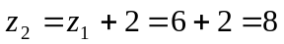

Continuing,
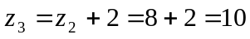
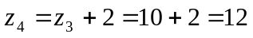

The previous example generated a basic linear sequence of real numbers. The same process can be used with complex numbers.

Example 16
Given the recursive relationship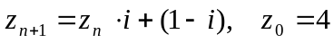, generate several terms of the recursive sequence.

We are given . Using the recursive formula:

Notice this sequence is exhibiting an interesting pattern – it began to repeat itself.

Mandelbrot Set
The Mandelbrot Set is a set of numbers defined based on recursive sequences

Mandelbrot Set
For any complex number c, define the sequence 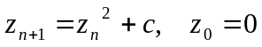

If this sequence always stays close to the origin (within 2 units), then the number c is part of the Mandelbrot Set. If the sequence gets far from the origin, then the number c is not part of the set.

Example 17
Determine if c = 1 + i is part of the Mandelbrot set.

We start with 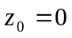. We continue, omitting some detail of the calculations
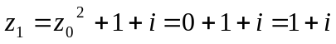
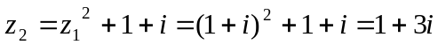

We can already see that these values are getting quite large. It does not appear that c = 1 + i is part of the Mandelbrot set.

Example 18
Determine if c = 0.5i is part of the Mandelbrot set.

We start with . We continue, omitting some detail of the calculations
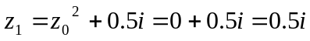

While not definitive with this few iterations, it does appear that this value is remaining small, suggesting that 0.5i is part of the Mandelbrot set.

Try it Now 5
Determine if c = 0.4 + 0.3i is part of the Mandelbrot set.

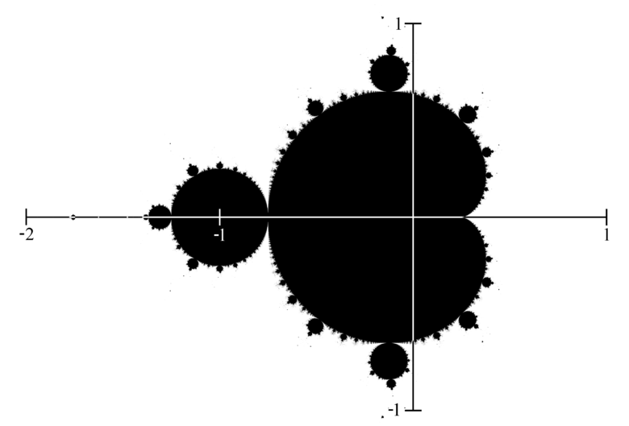
If all complex numbers are tested, and we plot each number that is in the Mandelbrot set on the complex plane, we obtain the shape to the right.

The boundary of this shape exhibits quasi-self-similarity, in that portions look very similar to the whole.

In addition to coloring the Mandelbrot set itself black, it is common to the color the points in the complex plane surrounding the set. To create a meaningful coloring, often people count the number of iterations of the recursive sequence that are required for a point to get further than 2 units away from the origin. For example, using c = 1 + i above, the sequence was distance 2 from the origin after only two recursions.

For some other numbers, it may take tens or hundreds of iterations for the sequence to get far from the origin. Numbers that get big fast are colored one shade, while colors that are slow to grow are colored another shade. For example, in the image below, light blue is used for numbers that get large quickly, while darker shades are used for numbers that grow more slowly. Greens, reds, and purples can be seen when we zoom in – those are used for numbers that grow very slowly.
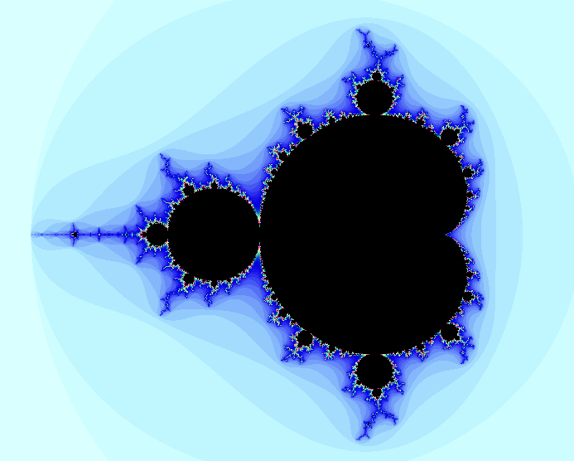
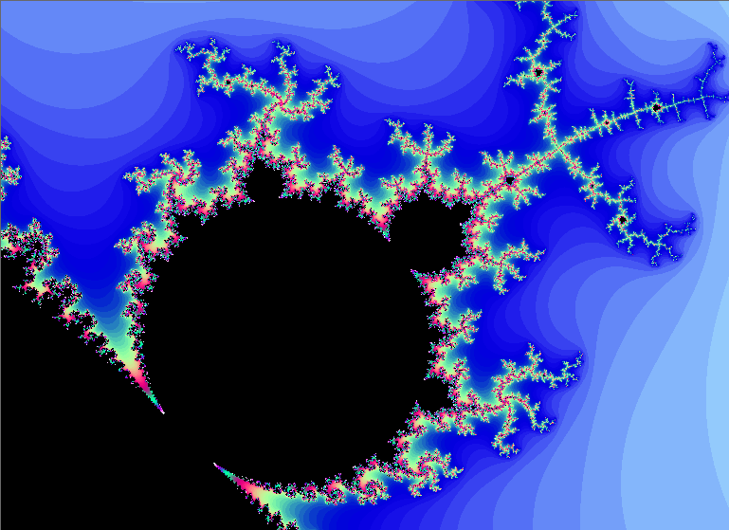
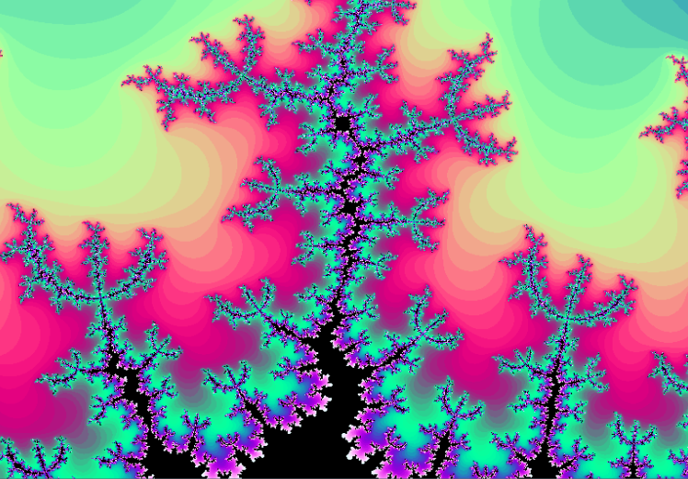

The Mandelbrot set, for having such a simple definition, exhibits immense complexity. Zooming in on other portions of the set yields fascinating swirling shapes.
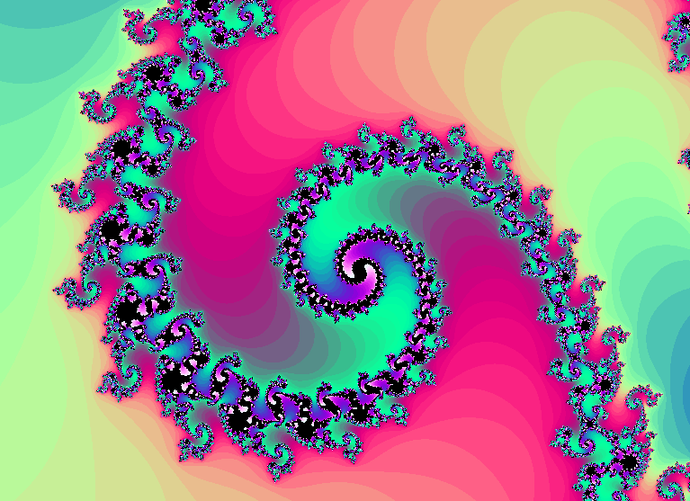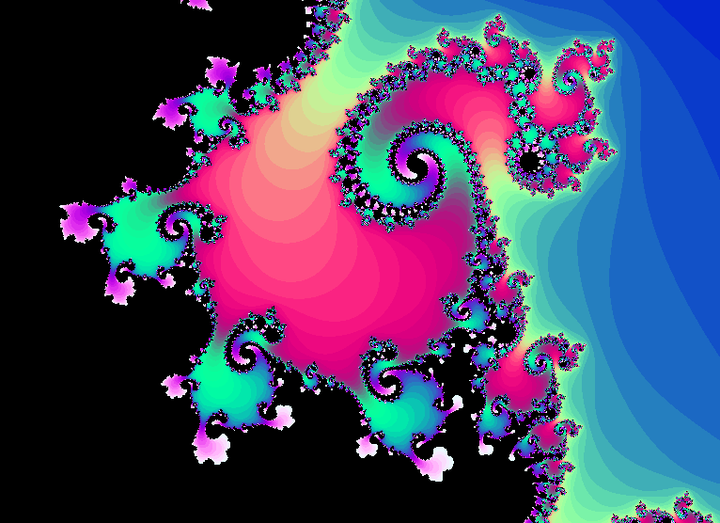
Try it Now Answers
1.
Step 2
Step 3

2.
1
3
Scaling the fractal by a factor of 3 requires 5 copies of the original. 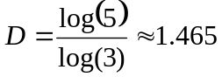

3. 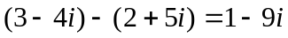

4. Multiply

5.

Additional Resources
A much more extensive coverage of fractals can be found on the Fractal Geometry site. This site includes links to several Java software programs for exploring fractals.

The Mandelbrot Explorer site, provides more details on the Mandelbrot set, including a nice visualization of Mandelbrot sequences.

Exercises

Iterated Fractals
Using the initiator and generator shown, draw the next two stages of the iterated fractal.

1. 2.
initiator
generator
initiator
generator

3. 4.
initiator
generator
initiator
generator

5. 6.
initiator
generator
initiator
generator

7. Create your own version of Sierpinski gasket with added randomness.

8. Create a version of the branching tree fractal from example #3 with added randomness.

Fractal Dimension
9. Determine the fractal dimension of the Koch curve.

10. Determine the fractal dimension of the curve generated in exercise #1

11. Determine the fractal dimension of the Sierpinski carpet generated in exercise #5

12. Determine the fractal dimension of the Cantor set generated in exercise #4

Complex Numbers
13. Plot each number in the complex plane: a) 4 b) –3i c) – 2 + 3i d) 2 + i

14. Plot each number in the complex plane: a) – 2 b) 4i c) 1 + 2i d) – 1 – i

15. Compute: a) (2 + 3i) + (3 – 4i) b) (3 – 5i) – (–2 – i)

16. Compute: a) (1 – i) + (2 + 4i) b) (–2 – 3i) – (4 – 2i)

17. Multiply: a) 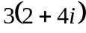 b) 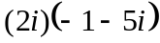 c) 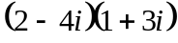

18. Multiply: a) 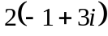 b) 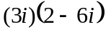 c) 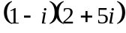

19. Plot the number 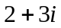. Does multiplying by 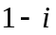 move the point closer to or further from the origin? Does it rotate the point, and if so which direction?

20. Plot the number . Does multiplying by 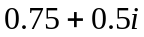 move the point closer to or further from the origin? Does it rotate the point, and if so which direction?

Recursive Sequences
21. Given the recursive relationship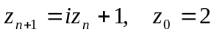, generate the next 3 terms of the recursive sequence.

22. Given the recursive relationship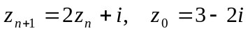, generate the next 3 terms of the recursive sequence.

23. Using c = –0.25, calculate the first 4 terms of the Mandelbrot sequence.

24. Using c = 1 – i, calculate the first 4 terms of the Mandelbrot sequence.

For a given value of c, the Mandelbrot sequence can be described as escaping (growing large), a attracted (it approaches a fixed value), or periodic (it jumps between several fixed values). A periodic cycle is typically described the number if values it jumps between; a 2-cycle jumps between 2 values, and a 4-cycle jumps between 4 values.

For questions 25 – 30, you’ll want to use a calculator that can compute with complex numbers, or use an online calculator which can compute a Mandelbrot sequence. For each value of c, examine the Mandelbrot sequence and determine if the value appears to be escaping, attracted, or periodic?

25. 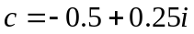. 26. 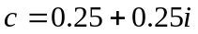.

27. 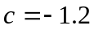. 28. 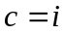.

29. 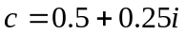. 30. 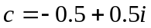.

31. 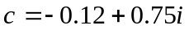. 32. .

Exploration
The Julia Set for c is another fractal, related to the Mandelbrot set. The Julia Set for c uses the recursive sequence: 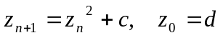, where c is constant for any particular Julia set, and d is the number being tested. A value d is part of the Julia Set for c if the sequence does not grow large.

For example, the Julia Set for -2 would be defined by 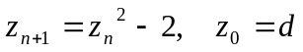. We then pick values for d, and test each to determine if it is part of the Julia Set for -2. If so, we color black the point in the complex plane corresponding with the number d. If not, we can color the point d based on how fast it grows, like we did with the Mandelbrot Set.

For questions 33-34, you will probably want to use the online calculator again.

33. Determine which of these numbers are in the Julia Set at 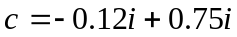
a) 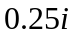 b) 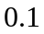 c) 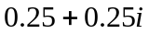

34. Determine which of these numbers are in the Julia Set at 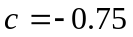
a) 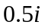 b) c) 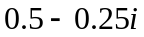

You can find many images online of various Julia Sets.

35. Explain why no point with initial distance from the origin greater than 2 will be part of the Mandelbrot sequence

http://en.wikipedia.org/wiki/File:Cauliflower_Fractal_AVM.JPG
http://www.flickr.com/photos/cjewel/3261398909/
Openstreetmap.org, CC-BY-SA
http://www.flickr.com/photos/visualarts/5436068969/
http://en.wikipedia.org/wiki/File:Fractal_tree_%28Plate_b_-_2%29.jpg
http://en.wikipedia.org/wiki/File:Barnsley_Fern_fractals_-_4_states.PNG
http://en.wikipedia.org/wiki/File:FractalLandscape.jpg
Portions of this section are remixed from Precalculus: An Investigation of Functions by David Lippman and Melonie Rasmussen. CC-BY-SA
http://en.wikipedia.org/wiki/File:Mandelset_hires.png
This series was generated using Scott’s Mandelbrot Set Explorer
For example, http://www.jcu.edu/math/faculty/spitz/juliaset/juliaset.htm,

